Create a Class

A circle in the Cartesian plane can be described uniquely by its centre and its radius. Thus, a class Circle that represents such circles should consist of information x-coordinate and y-coordinate of centre and radius.

1. Create a class Circle with the required instance fields.

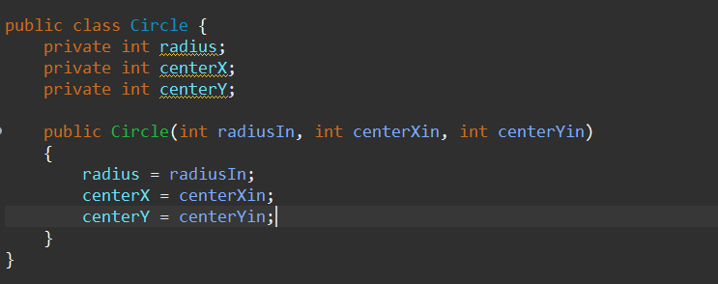

1. Write the accessor and mutator methods for the instance fields.

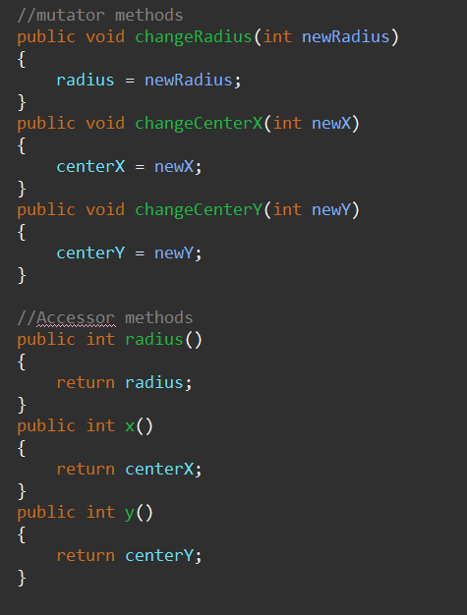

1. Write a constructor method that has no parameters. The method should construct a Circle object with centre (0,0) and radius 1.

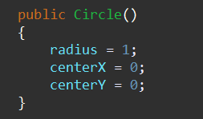

1. Write a constructor method that has three parameters representing the coordinates of the centre and the radius of the object to the constructed. The method should ensure that the circle’s radius is not negative by changing the sign of any negative radius parameters.

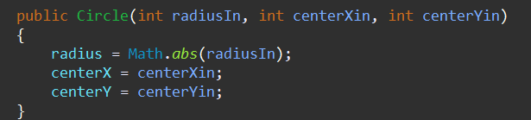

1. Write a constructor method with a parameter, an object of type Circle. The method should construct a new Circle object with the same field values as those of the parameter.

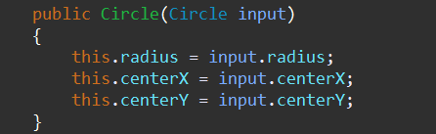

1. Write an instance method area that returns, as a double value, the area of its implicit Circle object.

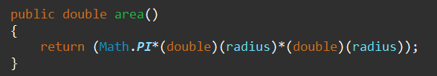

1. Write a method smaller that could be called by a statement like

c3 = c1.smaller(c2);

where c1, c2, and c3 are objects of type Circle. The method should make c3 refer to smaller of the circles represents by c1 and c2 (or c1 if c1 and c2 are the same size)

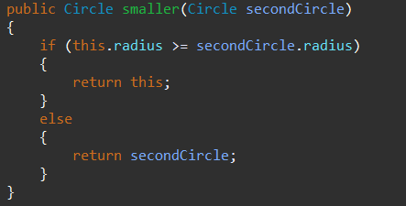

1. Write a method distance that would returns the distance between the centre of the two circles specified by the implicit and the explicit object parameters.



1. Write the boolean-valued instance method is isInside that could be called by a statement like

boolean contained = c1.isInside(c2);

The method should return true if c1 is entirely inside c2 and return false otherwise.

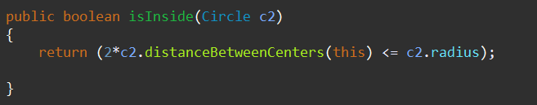

1. Write a boolean instance method called equals that return true if and only if one Circle has identical centre and radius as another one.

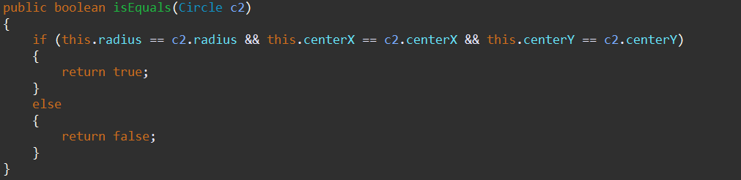

1. Write a toString method for the Circle class. For a Circle object with x = 3, y = -4, and r = 2, the toString method should return a String with the value:

“centre: (3, -4) radius: 2”.

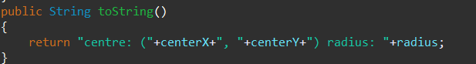

1. Create a class TestCircle which contains the main method. The main method should perform the following actions:
   1. Create two Circle objects c1, representing the circle with centre (4, -1) and radius 3, and c2, representing the circle with centre (3, -2) and radius 5.



* 1. Find and print the area of c1.

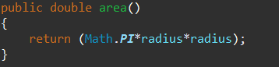





* 1. Determine the smaller of c1 and c2 and then print its centre and radius.

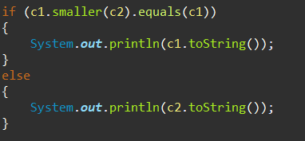



* 1. Determine whether or not c2 lies entirely within c1 and print an appropriate statement.

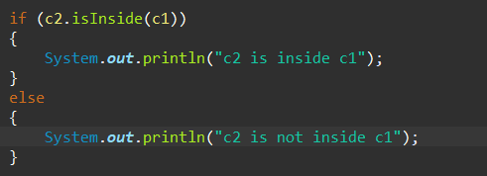



* 1. Create a new reference, c3, to c1



* 1. Create a new Circle object c4, with the same centre and radius as c1.

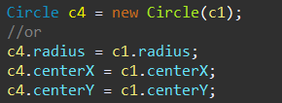

1. Draw diagrams to illustrate the results of executing the code in 12e and 12f.

| c1: Memory Address = Mc1 |
| --- |
| c1.radius = 3 |
| c1.centerX = 4 |
| c1.centerY = -1 |

**- >**

| c3: Memory Address = Mc1 |
| --- |
| c3.radius = c1.radius = 3; |
| c3.centerX = c1.centerX = 4 |
| c3.centerX = c1.centerX = 4 |

f)

| c1: Memory Address = Mc1 |
| --- |
| c1.radius = 3 |
| c1.centerX = 4 |
| c1.centerY = -1 |

Circle c4 = new Circle(c1)

*(c4.radius = c1.radius, c4.centerX = c1.centerX, etc)*

| c4: Memory Address = Mc4 |
| --- |
| c4.radius = 3 |
| c4.centerX = 4 |
| c4.centerY = -1 |

1. What is the value of the expression c1 == c3?

**True**, as c3 is a direct reference to c1 and both share the same memory address

1. What is the value of the expression c1 == c4?

**False,** as although the instance field of the c1 and c4 objects are identical, the memory addresses differ and since the “==” operator compares the memory address, it would return false.

1. What is the value of the expression c1.equals(c4)?

**True,** as this method compares the instance fields, comparing individual corresponding instance fields with the “==” operator is because of the primitive data type. Because the instance fields of c4 have the initialized to be identical to c1, it will return true.